**JavaScript Assignment 11 : Check if a Number is Even or Odd**

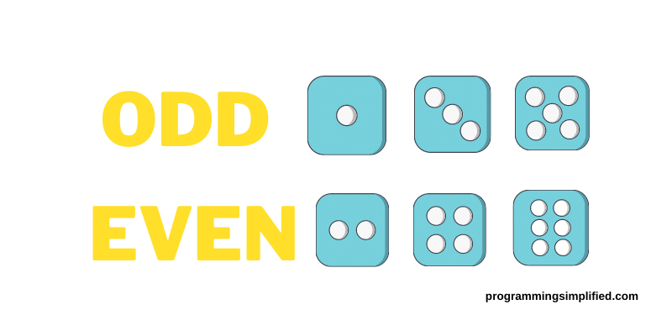

**Objective:** The objective of this assignment is to create a JavaScript program that checks whether a given number is even or odd.

[Link1](https://www.youtube.com/watch?v=9Ykz2_PhdfE)

[Link2](https://www.youtube.com/watch?v=3q7sk03ehOs)

**Tasks:**

* Write a JavaScript program that checks if a given number is even or odd.
* Use Three four different variables.
* Console.log a message indicating whether the number is even or odd.

**Instructions:**

Use an if-else statement to determine if the number is even or odd.

**Sample Output**:

The number 5 is odd.

The number 10 is even.

**Submission Guidelines :-**

* Deploy your code to netlify make sure to name your html file as index.html.
* If you don’t know how to deploy on netlify, watch this video : <https://youtu.be/Ii2Y4i4_i-o>
* Submit the Deployed Link below in the same task number

Submit the deployed link here: [https://upskillmafia.com/mern/dashboard/tasks](http://upskillmafia.com/mern/dashboard/tasks)

|  |
| --- |
| **Note :** You can take help from **Internet** or You can also connect with upskill Mafia **Mentors** |